**Introduction**

Hear this good people, on this day July 18, 1804, one week since the death of Alexander Hamilton and the madness does not end! This is not all, but one whole week after the unfolding of these events, our readers have only learned of escalation to the headline you see today. After learning there was no honorable agreement between Burr and Hamilton, and that they met in the same place where Hamilton’s son lost his life defending his fathers honor, Burr has been sought by the local New Jersey Authorities. People close to Hamilton, are unsure of his whereabouts as he fled after the duel on the morning of July 11, 1804, in cowardice. There are other mysteries surrounding the passing of our great writer, Hamilton, who detailed us thoroughly with his pen, of his great vision for unification throughout New England and the rest of the colonies. Our readers will remember the contentious publications directed by Hamilton and his associates which have been titled as “The Federalist Papers” are intertwined in the mystery that unfolds before us today.

Our readers in the Philadelphia area will have heard the loud boom and flash of lights in the dawning hours of sunlight just yesterday. By now word has spread that an investigation into the matter by local authorities revealed a strange shiny contraption, next to which a humanoid figure sat, almost awaiting the inevitable arrival. After clearly being of no threat, authorities soon learned that the tragic events that unfolded just one week ago with the passing of Hamilton have had monumental consequences on the future. The future you say? Yes, and we know this to be true through the man who arrived with the cracking of the skies just yesterday morning. This figure identified itself as Joseph Maugeri and knew factually of the time and means of death of our hero Hamilton. He said that he has come to not undo Hamilton’s passing, but rather ensure his work is immortalized in proper fashion. Our readers will remember our publication not three days ago which detailed the fact that several of the infamous “Federalist Papers” have disputed authorship, which has born out severe consequences on the reality from which the stranger Joseph comes. The man says that he cannot detail the specifics of why this is so important but said “events must play out as they must” along with other vague statements. The only definitive proclamation the stranger has made above all else is that they seek James Madison.

We at The Post feel that we must not ignore the moment. We issue a call to Madison to journey to Philadelphia to conference with this Stranger. It is evidently imperative for our nation’s security and is provable with the technology that the stranger has brought to examine the writings of Madison and Hamilton. We reserve the rest of the article for the strangers Research, please read and enjoy.

*Contextual Background: The Future*

Modern U.S. Government has collapsed in the world that I am from. It has been the fault of words on paper. A physical piece of paper that may be given a seal, ownership, or entitle the author to certain privileges. While the new age has brought the technology to enable time travel, we as a nation still rely on paper to execute functions of legislative bodies. In the future where I am from, The FDA (Food and Drug Administration of U.S) announced on June 8th, 2022, that it would begin to move away from its paper-based process of patient record keeping. That is right, even 200 years in the future our technology has not replaced the need for the same paper you read this on now. And the FDA are but one department that is designated to perform a function through legislation, which itself is created the legislative process. The acts that involve citizen requests being sent to government officials are still preserved on paper to the day I come from in the future. The work done by Hamilton, Madison and others all have created a still extant process. The oldest democratic practices around paper lawmaking are still used in legislative, judicial, and other official rooms. The delivery of information through a piece of paper. Stenographers, Politicians, Reporters, and politicians all use plain written language (albeit superfluous) to communicate information on current events and implications. The need to respond to the now can only be captured concretely with paper processes that have been practiced for centuries.

*Contextual Background: Fed. Papers*

“The Federalist Papers”, a series of publications which Alexander Hamilton outlined in the first to be…

"*Endeavor to give a satisfactory answer to all the objections which shall have made their appearance, that may seem to have any claim to your attention."*

…Were originally responses to articles published as “Anti-Federalist” Papers, which opposed the ratification of the Constitution as you know it. This collection of 85 papers were primarily authored by Madison or Hamilton, however there are 11 papers to which both lay claims. This mystery has been unsolved through to the time I am from, and I have calculated with my math that through resolving the issue today, I will alter the course of history to one which will preserve the U.S. I am unable to provide any other details other than it is imperative that James Madison immediately corresponds with me so that I may set to solving this issue; Who wrote truly wrote the 11 disputed papers, and was it really one author or another as we suppose now?

In the following section I will employ futuristic techniques that enable me to predict the true author of any paper based on the features of the papers with known authors. I will use words reflective of my time and will likely not be able to explain every example to the common reader.

* Joseph R. Maugeri IV

**Analysis**

*Data Pre-processing*

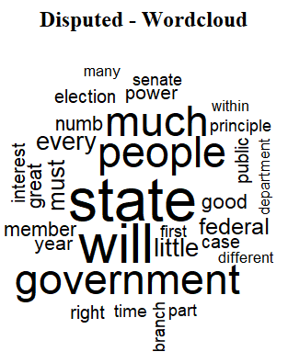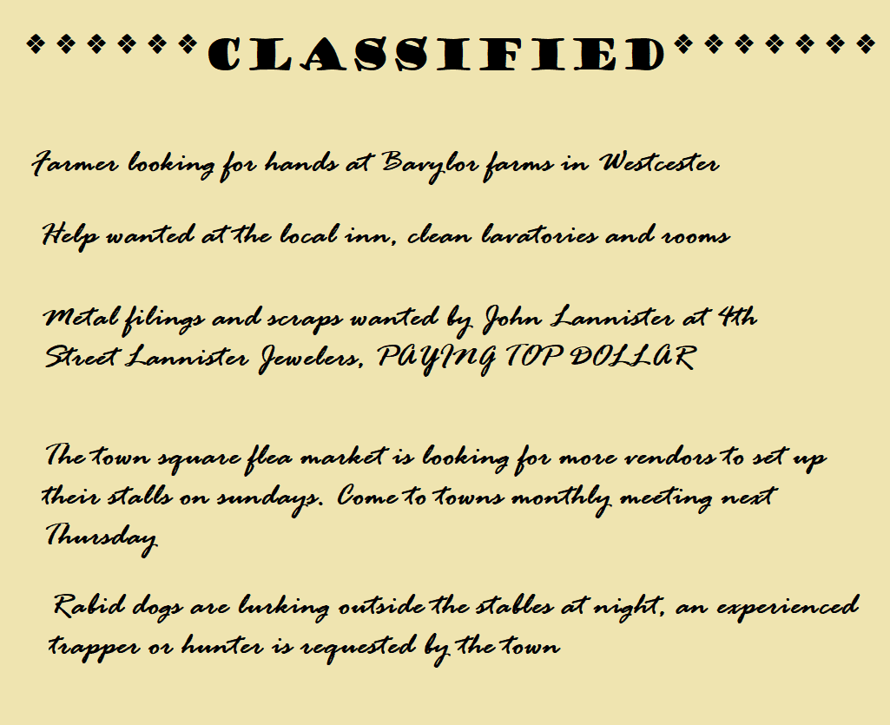The entire collection of federalist papers was first partitioned into folders of text documents. One folder held all papers with disputed authorship, and the other had papers of Hamilton or Madison as authors. Those folders were read into the R programming language and stored as corpus. To build the initial model the text files needed to be converted into document term matrices. Those were then converted into data frames which had labeling columns removed before using R was used to predict the authorship of the paper. The division of papers into corpus is critical as that establishes the frame of the prediction. All papers that were not specifically authored by Hamilton or Madison were removed from the corpus that was used to build the initial decision tree model.

*Word Clouds*

To get an initial look at the words used by the sets of papers considered (Hamilton, Madison, and disp) Word Clouds were generated (Left) to visualize the most frequently used words through size proportion.

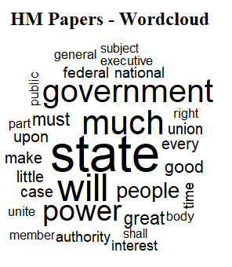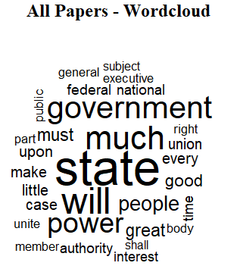

**Analysis**

*Decision Trees / Confusion Matrix: Building the Model*

The following Decision Tree was generated when using the Hamilton and Madison papers document term data frames to assess similarity.

The following confusion matrix was generated when using this decision tree to predict authorship and determine model validity.

**Analysis**

*Decision Trees / Confusion Matrix: Testing the Model*

The following Decision Tree was generated when using the entire set of known authored papers as data to predict the disputed authored papers.

The following confusion matrix was generated when using this decision tree to predict authorship.

**Results**

The results of using this data may seem to have proven that Hamilton was in fact the author of these papers. However, when looking between the first and the second decision tree (building and then applying the model) we notice the trees are the same in their proportions, and outputs. This is one problem with our results in that either we used something in the wrong place when building the model, OR we did not apply the model correctly.

The papers are highly complex data set, and in both instances a simple result has been given as the answer. This answer is associated with pure leaf nodes in both instances, which means that our model was able to purely classify papers as one author or another based on the conditions presented by the nodes. For both Trees there is only one node, which signifies the frequency of a word being used. That one word is the word “alexander” and the model suggest that in papers with word alexander occurring in frequencies of over 50% are papers authored by Alexander Hamilton. Frequency above .5 is interesting and would suggest that Hamilton either referenced himself often in his work or wrote his name a lot in the papers that he authored.

When looking at the confusion matrices, we notice that our building model did not get any of its predictions wrong. When looking at the applied confusion matrix, all of the disputed papers were written by “Hami” i.e., Hamilton. This high accuracy should not be trusted without additional testing and verification run. While the methods employed are relatively sound, they may not be perfect for understanding who authored a paper. The fact that the world alexander is the only deciding node in both instances is cause for alarm too, because if this was the same in the disputed papers, how could it be possible that there is any question of ownership when Hamilton is apparently plastering his name throughout his work?

Another issue with this data is despite the fact we had plenty of papers, we had unequal levels of authors within the papers. Hamilton wrote about 60% of the entire body of federalist papers, which makes his writing more relatable to any one paper alone purely because he has more available words to match than Madison. There were also several papers that were Co-Authored or authored by other infrequent authors. Attempts to normalize for these effects can be performed, but you are compromising the complexity of your dataset, with increasing complexity often leading to skewed results. It seems that we have witnessed overfitting in this instance as we had no failures at all, and a simple node that was a decision.

**Conclusion**

Ultimately the lack of variation between models and lack of errors is cause for a second review. When performing the techniques used to create decision trees there are many steps that must be performed to obtain usable data. Despite our best efforts with the technology the results are far too discrete to be considered accurate or conclusive. The inconclusive results have caused a stir in the year 2022, and many different methods beyond Decision Trees have been applied in attempt to root out the true author of these papers. All of them combined have been unable to reach a definitive conclusion.

The need for a definitive conclusion has warranted my usage of time altering technology to return myself to 1804 and find the true author of these papers. It would be foolish to return to a time prior to Hamilton’s death as that may alter the course of reality beyond repair. It has been decided that the most ethical method would be to return one week after Hamilton’s death and seek conference with James Madison regarding his writing. More samples of his and Hamilton’s work can be collected and used to better understand if Authors wrote the federalist papers in their own style, or another’s. It may be the case that both Hamilton and Madison adopted a style when approaching the subjects in the Federalist Papers, and through that we are unable to discern authorship through word usage.

As a member of the future, I understand all of this may truly be confusing or frightening. I ask that you trust I have yours and your nations best interests at heart with the work I seek to do here. If you can, direct this material to James Madison, and the family of Alexander Hamilton. They must be called to action (yet again) for as it stands now we are relying on them to build the nation, and bring it back from extinction. You will find me staying at the Lannister Tavern on 4th street, and will be rewarded heftily if you are able to assist in delivering Madison to me.